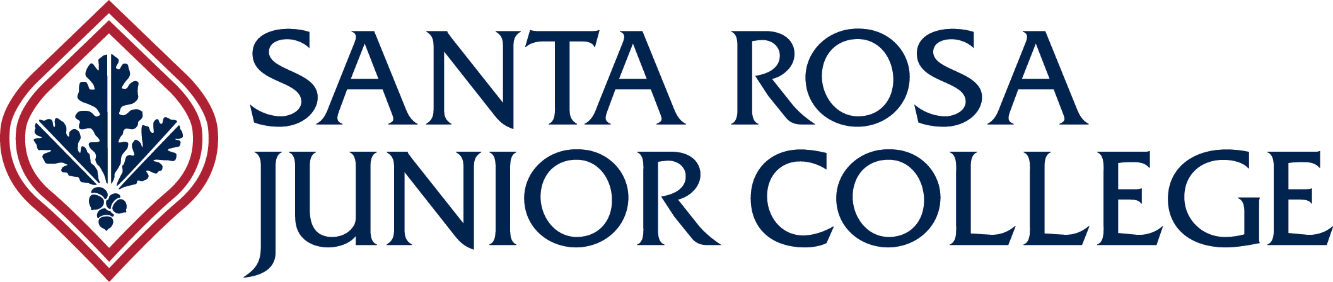
fitSRJC Standing Committee

MEETING

Wednesday, June 13, 2018

3:15 pm

Maggini 2825

AGENDA

Call In Info:
888-450-4821
Presenter Pin (for host): 1898261
Participant Pin (for attendees): 981890

- Kaiser Sponsorship—Jeannie Dulberg

- fitSRJC Community Ed Courses Update—Kim

The next meeting will be on Wednesday, June 27, 3:15pm in Maggini 2825.

