**HOW TO RANK ALL THE REQUESTS IN YOUR CLUSTER**

Log in to PRPP

Open up one of the PRPPs in your cluster, except for your own Dean PRPP. Do not open your Dean PRPP, as this will not allow you to retrieve and rank all the requests from different departments in your cluster at once.

Click on the Excel icon toolbar button at the top of the screen to bring up the Export Spreadsheet Data screen.

Click the “editing is disabled – enable editing” toolbar button on the Export screen (6th from the left) to enable editing. The red X on the toolbar button icon will disappear.

Click the leftmost toolbar button on the Export screen to bring up the Select Records screen. The Component and Sub Component (Cluster) options will be grayed out and set to the name of your cluster. The Program/Unit option will default to all the program/units in your cluster. The screen should look like this:

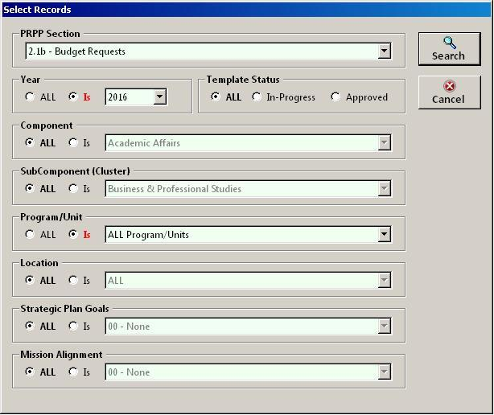

Select the PRPP section you want to rank and click the Search button. All the requests in your cluster will be displayed in the grid. You can then add your cluster rankings in the Supv Rank column. You cannot add or delete records from the grid but you can edit the other columns if necessary. The grid should look like this:

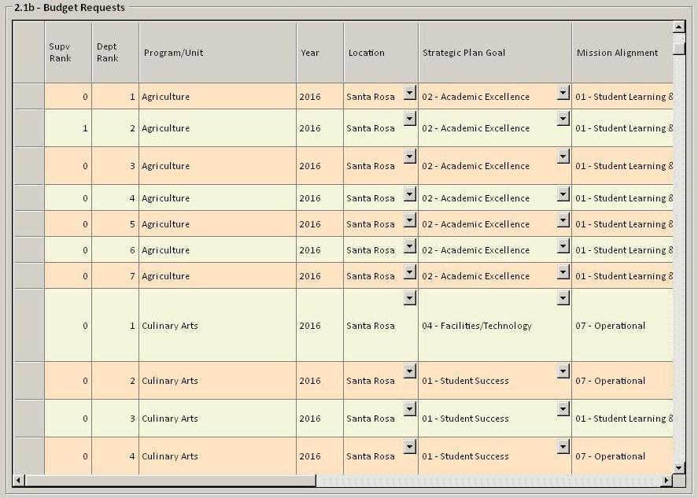

List your instructional Equipment requests in **rank order**, in the table provided.

Rank for Instructional Equipment: Assign a numerical ranking that begins with the number 1 (1, 2, 3…).  Assign each item a separate rank (do not use any ranking more than once except to group related items that must be purchased together). Rank only those items that require funding. DO NOT rank those items for which you have confirmed funding and are including in this section only for documentation and planning purposes.

Rank for Software: Assign a numerical ranking that begins with the number 50 (50, 51, 52…) Assign each item a separate rank (do not use any ranking more than once except to group related items that must be purchased together).  Make sure you have indicated Item Category “03-Software” for these selections so they do not get intermixed with rankings for Instructional Equipment. Rank only those items that require funding. DO NOT rank those items for which you have confirmed funding and are only including in this section for documentation and planning purposes.

After the ranking is complete, all items are exported to a master database for allocation based on available funds.