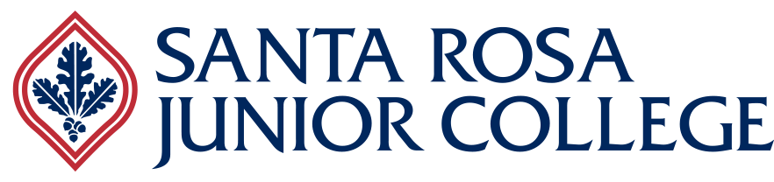

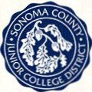

2014-19

Strategic Plan

**Our Vision**

*Santa Rosa Junior College aspires to be an inclusive, diverse and sustainable learning community that engages the whole person.*

**Our Mission**

*Santa Rosa Junior College passionately cultivates learning through the creative, intellectual, physical, social, emotional, aesthetic and ethical development of our diverse community.*

* We focus on student learning by preparing students for transfer; by providing responsive career and technical education; and by improving students' foundational skills.
* We provide a comprehensive range of student development programs and services that support student success and enrich student lives.
* We support the economic vitality, social equity and environmental stewardship of our region.
* We promote personal and professional growth and cultivate joy at work and in lifelong learning.
* We foster critical and reflective civic engagement and thoughtful participation in diverse local and global communities.
* We regularly assess, self-reflect, adapt, and continuously improve.

**Our Values**

**We value *Learning* that includes:**

* Excellent and innovative instruction and support services
* A learning- and learner-centered environment
* A welcoming physical environment
* A caring and supportive attitude among faculty and staff Access to programs and courses that lead to transfer and/or gainful employment

**We value *Academic Excellence* that includes:**

* Academic freedom balanced with academic responsibility, integrity and ethical behavior
* Effective and transparent communication with information being shared in a timely fashion
* Collaboration in continuous quality improvement of SRJC's programs and services

**We value *Sustainability* that includes:**

* The teaching of sustainability principles and concepts
* Research on sustainable development projects/issues
* Incorporating ecological values and practices in the District's operations
* Support and promotion of sustainability efforts in our community
* Fiscal solvency and stability

**We value *Diversity* that includes:**

* Equal access for all students
* Multi-ethnic global perspectives and cultural competencies
* Employees who reflect the communities we serve
* Honesty and integrity in an environment of collegiality and mutual respect

**We value *Community* that includes:**

* Community partnerships and advocacy for workforce and economic development
* Cultural enrichment opportunities
* Lifelong learning

**We value *Beauty* that includes:**

* Well-maintained and aesthetically pleasing facilities and grounds
* Holistic wellness
* Joy in learning and work

**We value *Compassion* that includes:**

* Helping students develop a vision for their lives
* Civic engagement opportunities that contribute to real world problem solving
* Empathy to identify the challenges and address the needs of others Collaborative leadership

**We value *Innovation* that includes:**

* Creativity, openness and risk taking
* Multiple perspectives
* Response to demographic, global, and technological changes

*We balance and integrate core values to assure the success of our diverse learning communities.*

**Our Goals and Objectives**

*In support of the Sonoma County Junior College District's vision mission, and values, we are committed to the following goals and strategic objectives:*

**A. Support Student Success**

* Support development of the whole student from early college awareness through successful completion of educational and career goals
* Expand and sustain access by eliminating barriers, expanding strategic outreach efforts, and delivering services effectively through current technologies
* Increase retention and academic progress through student engagement with: academic and student services, faculty and staff, and campus and community activities
* Increase the number of students who complete their educational plans and goals
* Enhance cultural competency to better serve all student populations with a focus on first generation college students and the increasing Latino/a population

**B. Foster Learning and Academic Excellence**

* Foster learning and academic excellence by providing effective programs and services
* Support and promote teaching excellence across all disciplines
* Engage students and spark intellectual curiosity in learner-centered environments
* Integrate academic and student support services across the college
* Identify and implement responsive instructional practices that increase the learning and success of our diverse students

**C. Serve our Diverse Communities**

* Serve our diverse communities and strengthen our connections through engagement, collaboration, partnerships, innovation, and leadership
* Identify the educational needs of our changing demographics and develop appropriate and innovative programs and services with a focus on the increasing Latino/a population
* Contribute to the richness of our multicultural community by promoting cultural initiatives that complement academics and encourage the advancement and appreciation of the arts
* Meet the lifelong educational and career needs of our communities {e.g. seniors, emerging populations, veterans, re-entry students)
* Provide relevant career and technical education that meets the needs of the region and sustains economic vitality

**D. Improve Facilities and Technology**

* Provide, enhance, integrate, and continuously improve facilities and technology to support learning and innovation
* Incorporate best practices and innovations for facilities and technologies in order to enhance learning and working environments
* Improve and sustain Infrastructure, facilities, and technology to proactively support our diverse learning community
* Increase District-wide coordination and collaboration to improve facilities and technology access, efficiency,
* and effectiveness
* Provide effective facilities and technology technical training for all employees to ensure operational effectiveness

**E. Establish a Strong Culture of Sustainability**

* Establish a culture of sustainability that promotes environmental stewardship, economic vitality, and social equity
* Expand, support, and monitor district-wide sustainability practices and initiatives
* Infuse sustainability across the curriculum and promote awareness throughout District operations
* Promote social and economic equity in the communities we serve
* Ensure economic sustainability by leveraging resources, partnering with our communities, and contributing to the economic growth of the region

**F. Cultivate a Healthy Organization**

* Cultivate an inclusive and diverse organizational culture that promotes employee engagement, growth, and collegiality
* Foster an environment focused on collegiality and mutual respect in regards to cultural and individual perspectives
* Recruit and hire outstanding faculty and staff and implement an exemplary Professional Development Program for all employees
* Establish robust programs to improve the health and wellness of students and employees
* Increase safety planning, awareness and overall emergency preparedness

**G. Develop Financial Resources**

* Pursue resource development and diversification while maintaining responsible fiscal practices and financial stability
* Increase the amount of discretionary, unrestricted general fund local revenue
* Increase and maintain the District reserves above the state requirements
* Pursue alternative funding sources including grants, partnerships, and scholarships to support our diverse communities and students
* Manage enrollment and course offerings to maximize apportionment funding

**H. Improve Institutional Effectiveness**

* Continuously improve institutional effectiveness in support of our students, staff, and communities
* Fully implement continuous quality improvement strategies to achieve greater transparency, effectiveness, efficiency, and participation
* Enhance Internal and external communication systems to ensure effectiveness