Santa Rosa Junior College
Program and Resource Planning Process (PRPP)
Navigation and Editing Instructions
2020-21 Planning Cycle
Revised February 2020

Table of Contents

I. BACKGROUND 1
Improvements for the Annual PRPP Cycle (2020) 1
II. PRPP TABLE OF CONTENTS 2
III. Accessing data and documents related to the PRPP 4
PRPP Data Documents in Sharepoint 4
IV. Accessing the PRPP Template 5
CITRIX 5
How to log in and edit a PRPP template via CITRIX 5
HORIZON 9
How to log in and edit a PRPP template via HORIZON 9
V. RESOURCE REQUESTS 13
2.1b) Budget Requests 13
2.2c) Classified, Management, Student or STNC Requests 13
2.4a) Desktop Technology requests 13
2.4c) Instructional Equipment and Software Requests (Update every spring) 13
2.4d) Non-Instructional Equipment and Technology Requests (Update every spring) 15
2.4f) Instructional/Non-Instructional Software Requests (Update every spring) 15
2.5a) Facilities 16
6.3a) Annual Plan: Ongoing Operations 17
6.3b) Institution-wide or Cross-Component Planning 17
VI. CRITERIA FOR PRIORITIZATION OF RESOURCE REQUESTS 18
VII. INSTRUCTIONS FOR SUPERVISING ADMINISTRATORS 19
How to rank all the requests in your cluster 19
Instructional Equipment Process 21
VIII. REFERENCE INFORMATION 23
Strategic Plan Goals 23
Mission Alignment 23
Institutional Student Learning Outcomes (I-SLOs) 24

Santa Rosa Junior College
Program and Resource Planning Process (PRPP)
Navigation and Editing Instructions
2020-21 Planning Cycle
Revised February 2019

BACKGROUND

The purpose of this document is to provide navigation instructions for the PRPP template, and to provide some detail on navigating the different types of resource requests in the PRPP.

Improvements for the Annual PRPP Cycle (2020)

The faculty, staff and administrative members of the Institutional Planning Council and PRPP Coordinating Committee work closely with the President’s Cabinet and department chairs to continuously improve our integrated planning process. Based on your feedback and thoughtful suggestions, we offer some reminders and examples of this year’s improvements.
- This year is an Annual Planning Cycle, where fewer sections (only Sections 2 and 6) are required. Section 5.11a is required for all Career Education programs.

- Institutional technology funding requests (Measure H bond funded) are included in the PRPP but follow a different deadline schedule. A separate email notification has been sent to Department Chairs and Managers from the ITG co-chairs outlining details of the process. The timeline for submitting these requests allows for more time than in prior years – requests must be made by March 25th to be considered for funding for the 2020/21 academic year. Enter all technology requests in the PRPP sections 2.4c and 2.4d.

- Please refer to the 2020 Writer's Guide, which can be accessed from the PRPP SharePoint site, for more information. For 2020, the only section change was to 6.2b – PRPP Editor Feedback (Optional).

- The PRPP template is accessible via CITRIX and the new VMHWare HORIZON client. To access either, go to the Information Technology website (https://it.santarosa.edu/) and use the “Web Links and Portals” drop down box to click on either “CITRIX Login” or “Horizon Login.” Look for a dl.staff.all message from IT for more information about accessing the PRPP template and what to do if you run into difficulties.

- The PRPP Coordinating Committee is committed to continuously improving the PRPP process. To that end, please know that all PRPP reports will receive additional review this year to ensure a quality process. Additionally, there will be a more comprehensive evaluation of the PRPP process in late spring.
Notes:
- For your reference, changes from prior years are in RED FONT throughout this document.
- The “PRPP Writer’s Guide” is an invaluable resource to PRPP editors. Different than this document, the Writer’s Guide gives definitions, tips and instructions for every section of the PRPP template. The Writer’s Guide is accessible via the PRPP documents on the PRPP Sharepoint site, and instructions for each section in the Writer’s Guide is embedded in the PRPP template for easy access.

PRPP TEMPLATE TABLE OF CONTENTS

PRPP Sections | How Often to Update?
1.1a Mission | Every Third Year  (next due 2022)
1.1b Mission Alignment | Every Third Year  (next due 2022)
1.1c Description | Every Third Year  (next due 2022)
1.1d Hours of Office Operation and Service by Location | Every Third Year  (next due 2022)
1.2 Program/Unit Context and Environmental Scan
2.1a Budget Needs | Update Every Year
2.1b Budget Requests | Update Every Year
2.2a Current Classified Positions | Update Every Year
2.2b Current Management/Confidential Positions | Update Every Year
2.2c Current STNC/Student Worker Positions | Update Every Year
2.2d Adequacy and Effectiveness of Staffing | Update Every Year
2.2e Classified, STNC, Management Staffing Requests | Update Every Year
2.3a Current Contract Faculty Positions | Update Every Year
2.3b Full-Time and Part-Time Ratios | Update Every Year
2.3c Faculty Within Retirement Range | Update Every Year
2.3d Analysis of Faculty Staffing Needs and Rationale to Support Requests | Update Every Year
2.3e Faculty Staffing Requests | Update Every Year
2.4a Desktop Technology Equipment Requests | Update Every Year
2.4b Rational for Instructional and Non-Instructional Equipment, Technology, and Software | Update Every Year
2.4c Instructional Equipment Requests | Update Every Year
2.4d Non-Instructional Equipment and Technology Requests | Update Every Year
2.4e Safety, Utility, and ADA Impacts | Update Every Year
2.4f Instructional and Non-Instructional Software | Update Every Year
2.5a Minor Facilities Requests | Update Every Year
2.5b Analysis of Existing Facilities
3.1 Develop Financial Resources | Update Every Third Year  (2019)
3.2 Cultural Competency | Update Every Third Year  (2019)
3.3 Professional Development | Update Every Third Year  (2019)
3.4 Safety and Emergency Preparedness* Submit as occur using Environmental Health and Safety Form | Update Every Third Year  (2019)
3.5 Sustainable Practices | Update Every Third Year  (2019)
4.1a Course Student Learning Outcomes Assessment | Update Every Third Year  (2019)  4.1a and 4.1b are only required for Academic Affairs or Student Services Programs that offer courses and/or programs
4.1b Program Student Learning Outcomes Assessment
4.1c Student Learning Outcomes Reporting no longer required
4.2a Key Courses or Services that address Institutional Outcomes
4.2b Narrative (Optional)
5.0 Performance Measures | Update Every Third Year  (next due 2022)  NOTE: 5.1 to 5.9b are only for Academic Affairs or Student Services Programs that offer courses  Update Every Second Year  (next due 2020)
5.1 Effective Class Schedule
5.2a Enrollment Efficiency (“Fill rate”)
5.2b Average Class Size
5.3 Instructional Productivity
5.4 Curriculum Currency
5.5 Successful Program Completion
5.6 Student Success
5.7 Student Access
5.8 Curriculum Offered Within Reasonable Time Frame
5.9a Curriculum Responsiveness
5.9b Alignment with High Schools (Tech-Prep ONLY)
5.10 Alignment with Transfer Institutions (Transfer Majors ONLY)
5.11a Labor Market Demand (Career Education Programs ONLY)
5.11b Academic Standards
6.1 Progress and Accomplishments Since Last Program/Unit Review | Update Every Year
6.2b PRPP Editor Feedback (Optional) | Update Every Year
6.3a Annual Unit Plan | Update Every Year

Accessing data and documents related to the PRPP

The easiest portal into the PRPP and related documents is via the SRJC Planning website, where you will see a heading for PRPP (Program and Resource Planning Process/Program Review/Program Evaluation):
https://planning.santarosa.edu/
- Click on the link that says “2020 PRPP Template and Data”
- You will be taken to a Share Point PRPP site. When you access SharePoint for the first time, you will need to use this logon:
E-mail name.@ad.santarosa.edu
Example: cprince@ad.santarosa.edu
Go to the following link that explains how to log on the first time:|
https://bussharepoint.santarosa.edu/SitePages/Error.aspx
- Subsequently you will be able to just use your SRJC Outlook username and password to logon.

PRPP Data Documents in Sharepoint
A new window will open. You can choose from a number of folders:
- 2020 Academic Affairs Docs – Configuration, Core, and Academic data (alpha sort), Student Equity data, FT/PT faculty percentages, Faculty within Retirement Range, and curriculum currency list.
- 2020 Finance and Admin Services Docs – Configuration and Core data (alpha sort)
- 2020 Human Resources Docs – Configuration and Core data (alpha sort)
- 2020 Petaluma Campus Docs – Configuration and Core data (alpha sort)
- 2020 President’s Office Docs – Configuration and Core data (alpha sort)
- 2020 Priorities – prioritized lists will be posted here
- 2020 Student Services Docs – Configuration, Core data and student services data
- Warehouse (older documents) - previous years archived documents
- 2020 PRPP Navigation and Editing Instructions
- How to Rank the Requests in Your Cluster
- PRPP Template Documentation (For PRPP Administrators)
- PRPP Writer’s Guide – 2020 - FINAL
- PRPP_2020_District_Total_FY18-19_Acad
- PRPP_2020_District_Totals_FY18-19_Core

Accessing the PRPP Template

The PRPP template is accessible via CITRIX, as it has been. In the future, SRJC will be migrating away from CTRIX, to the new VMWare HORIZON client. This year, there is a choice to either access via CITRIX, as in the past, or via HORIZON. Many report that HORIZON provides an easier user interface. The instructions, below, show CITRIX access and navigation instructions. If you prefer to try HORIZON this year, go to page 9 for the HORIZON login instructions.

CITRIX
The easiest portal into the PRPP and related documents is via the SRJC Planning website, where you will see a heading for PRPP (Program and Resource Planning Process/Program Review/Program Evaluation):
https://planning.santarosa.edu/

To begin work on the PRPP, you must connect through the Citrix server. This can be done through the link on the planning website, or by this direct link: https://citrix.santarosa.edu. If you have trouble connecting, please uninstall your existing old Citrix client, reboot your machine, and attempt the connection again. Visit the link below for Citrix support information.
http://www.santarosa.edu/administration/administrative-services/information-technology/support/citrix/

Remember to update your shortcuts and favorites.

How to log in and edit a PRPP template via CITRIX

1. Any editor or approver can access the PRPP template with an SRJC email name and password. The easiest portal into the PRPP and related documents is via the SRJC Planning website, where you will see a heading for PRPP (Program and Resource Planning Process/Program Review/Program Evaluation): https://planning.santarosa.edu/.

Alternatively, you can go to CITRIX directly and click the icon for PRPP. Or, go to www.santarosa.edu/prpp . (If you do not have access to PRPP, email your supervisor for approval. The supervisor should approve and forward the request to Patty Collis in Information Technology.)
- Click the box called Link to PRPP Template (yellow box at the top of the page).
- This takes you to CITRIX. Log on using your email name and password. (Note: If you do not have CITRIX, it may need to be installed on your computer. Call the Information Technology Help Desk at extension 1765)
- Choose the icon called PRPP (a little red toolbox).
- Click OK indicating that you are an authorized user.
- Enter your user name and password exactly as you enter them for campus email.
- Click the Log On button.

2. The “Select Program/Unit Template” screen will appear.
- Component – choose your component from the drop down menu (optional)
- Program Unit – select your program/unit from the drop-down menu (required)
- Show Program/Units I can edit – click this button to show only the program/units you are allowed to edit (optional). This narrows the choices.
- Choose the last row on the list by clicking that row. Each row of the table is a different year. (It will say “In Progress” if the PRPP can be edited.)
- Click OK button.

3. An Edit Template screen will appear. To the left you will see a navigational tree listing the PRPP sections. This is a “tree view,” so that you can open any or all sections of the PRPP in order to navigate. Click on the plus sign (+) to open each section. Click on a minus sign (-) to close a section. Click on the subsection you wish to view.

4. Data Entry Text Screens. The data entry screens with text blocks act very similar to word processing. Some basic word processing features are available on the screen. You can copy and paste text, tables, or graphs into these screens. In the upper right hand corner, you can choose to see only the PRPP document or you can choose to show multiple items on your desktop.

5. Prompts. To see the prompt questions and instructions for each screen, click on the little question mark icon above the text block and editing tools. This brings up the questions and instructions for that screen. To view all of the prompts and instructions in one document, download the Writer’s Guide (explained on page 1). The complete Writer’s Guide is also viewable from the Template by clicking the 5th toolbar button from the left.

6. Spreadsheet Tables
- Spreadsheets are flagged with a green “excel” icon in the tree view. Click on the item you wish to view.
- On the far left (grey column), click on any row to highlight it and make changes
- To sort the items in ranked order (1,2,3…), click the label on Dept Rank column.
- Supervisors only will have access to Supv Rank column for their prioritization
- To add a new entry, click on the bottom row of the spreadsheet.
- For Strategic Plan Goal, chose one item from the drop down menu.
- For Mission Alignment, choose one item on the drop down menu.
- For Responsibility Code (RS), pick your own (if listed) or your supervisor’s code from the drop down menu.
- To delete a row, select the entire row you wish to delete, and choose Delete on your keyboard

The spreadsheets are wide, so the entire spread sheet may not be showing on your screen. You may need to use the scroll bar at the bottom of the screen to view and complete all columns. As with excel, you can make the columns narrower if you choose.

These all contain similar fields, which may include:
- Department Rank = program/unit priority for this item. Number items 1,2,3 – don’t duplicate numbers. Combine related items in one line if they truly need to be ordered together. (Note Supervisor Rank and VP Rank can only be viewed by those administrators)
- RS- Responsibility Code. Drop down menu. Choose the Supervising Administrator that your program/unit reports to. Deans, VPs, and President, select your own responsibility code.
- ACTV. Enter the 4-digit budget activity code for your program/unit. This is now pre-populated, so change it only if it is not correct.
- Object. If this field is required, enter the budget object code, such as 4390 for supplies.
- Location. Choose which location this request relates to. If it relates to the program as a whole in all locations, choose ALL.
- Strategic Plan Goals. Choose which goal (#1 – 8) of the Strategic Plan your request relates to. (That information is in this guide for easy reference.)
- Mission. Choose which aspect of the College mission your request relates to. If the request is a routine type of request, you may choose “operational.” (That information is in this guide for easy reference.)
- Amount. Enter the amount without the $ sign – the software adds the $ sign and two decimal places, such as $700.00.
- Brief Rationale. Keep rationales very brief. The data exports to spread sheets. You can explain in more detail in the narrative portions of the document.

7. Toolbar Functions (icons)
- PRPP Administrator Tools – used by PRPP Admins to maintain system-wide configuration information and pull District-wide master spreadsheets. These tools are documented in a separate document.
- Logon – logon as another user.
- Select PRPP Template – selects a PRPP template to view and/or edit.
- View Template Information – displays information about the template.
- View PRPP Writer’s Guide – displays the current PRPP Writer’s Guide document.
- Clear Textbox – clears all the text from the text-section edit window. Disabled when editing a spreadsheet-section.
- Save Text Changes – saves changes made to the text-section edit window. Disabled when editing a spreadsheet-section.
- Create Documents – saves the contents of the template as a Word document. Disabled if the user does not have a home directory.
- Create Spreadsheets – exports information from spreadsheet-sections. Saving the information is disabled if the user does not have a home directory.
- Request Template Approval – sends an email to the template approver requesting approval of the template.
- Reject Template Approval – sends an email back to the template editors explaining why the template wasn’t approved. Disabled if the user is not an approver.
- FINAL Approval of Template – approves the template. Once a template has been approved it can no longer be edited. PRPP Admins can re-open the template for editing on request. Disabled if the user is not an approver.
- Increase Template Font Size – increases the font size displayed in the treeview and spreadsheet-sections. This does not affect the font sizes of the text-sections.
Decrease Template Font Size – decreases the font size displayed in the treeview and spreadsheet-sections. This does not affect the font sizes of the text-sections.
View Section Help – displays help/instructions for the current section being edited. The help for each section is also found in the PRPP Writer’s Guide document.

8. How to Copy and Paste
To copy and paste text from one area to another, or from a word document into the PRPP template, you can use the following keystrokes:
To copy = control + “c” (PC) or apple + “c” (MAC)
To paste = control + “v” (PC) or apple + “v” (MAC)

You cannot use this technique for copying spreadsheets type of information---just blocks of text.

9. To view any approved PRPP. See instructions for numbers 1 to 3 above. Instead of editing the PRPP, just use the navigation tree to read any sections you are interested in. You can also save the document, as described in #8.

10. View as Approver
In the upper left of the screen near the icons, you will see a drop down menu called View as Approver. It provides two choices:
- View as approver (for deans and VPs). This is used by cluster deans and Vice-Presidents to prioritize the needs of their own areas of supervision.
- View as editor (for most other people). This allows normal editing and allows program/units to prioritize research requests.

HORIZON

HORIZON is currently in production, but functions for PRPP. SRJC editors and approvers have the option of accessing the PRPP template via either CITRIX, or HORIZON.

How to log in and edit a PRPP template via HORIZON

Login instructions for HORIZON are outlined below. Once you have logged in, you can follow the navigation instructions outlined above.
- Open a web browser and input the following URL: https://horizon.santarosa.edu
- Select the “Install VMWare Horizon Client”

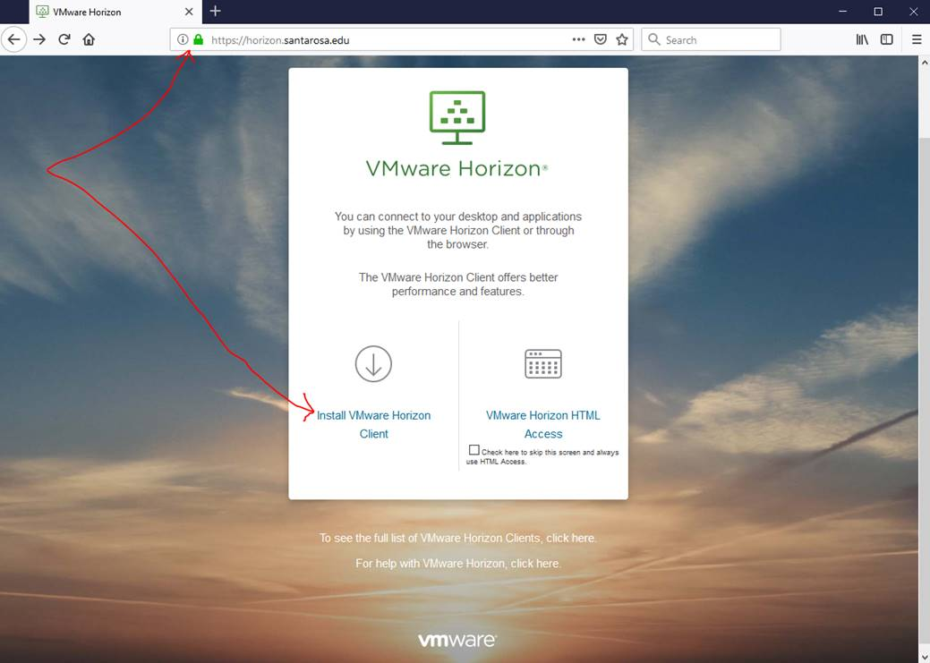

- On the “Download VMWare Horizon Clients” page, select the appropriate client for your operating system and select “Go to Downloads”. I.E. Windows, Mac, etc.
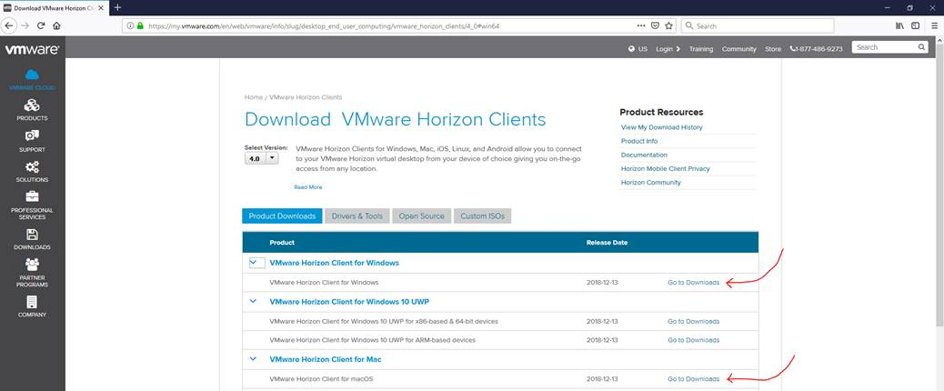

- Select “Download” on the following page. Once the client software is downloaded to your computer, install the Horizon client.
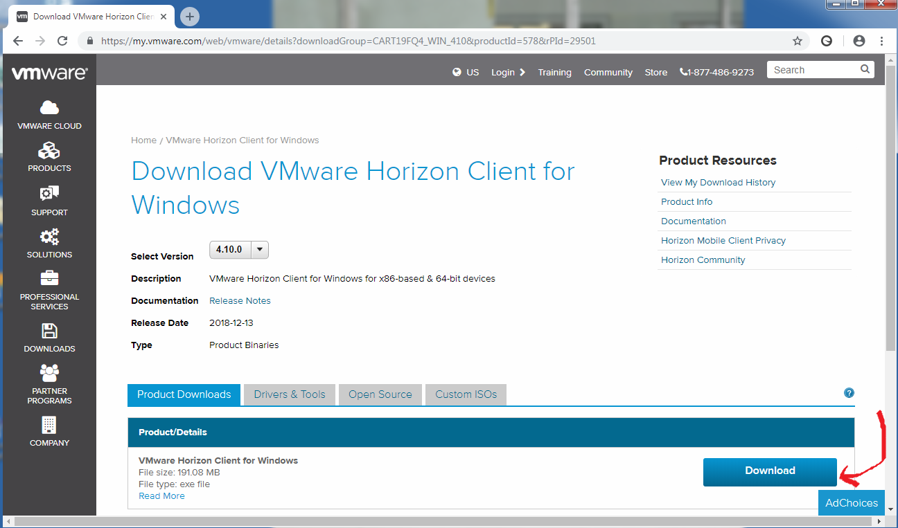

- After the installation is complete, launch the Horizon software from your computer.
- Select “New Server” and then input https://horizon.santarosa.edu in the “Enter the name of the Connection Server” field. Click “Connect”
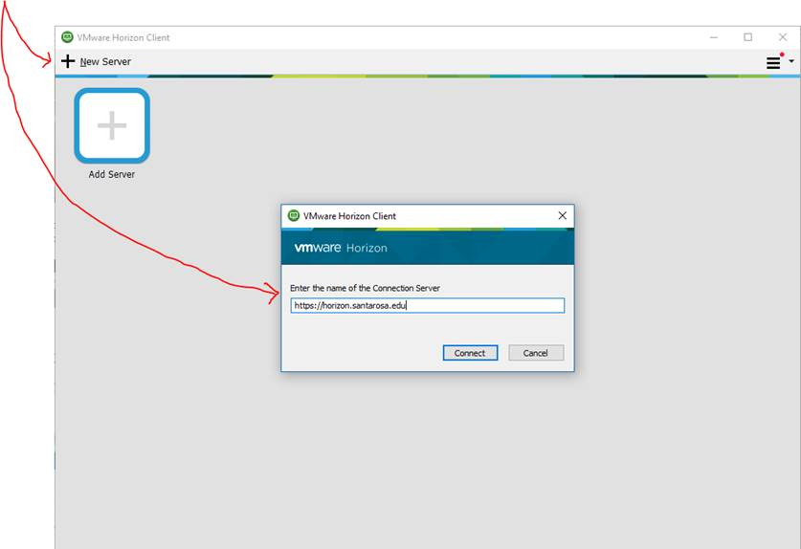

- Enter your SRJC credentials in the User name/Password fields and select “Login”
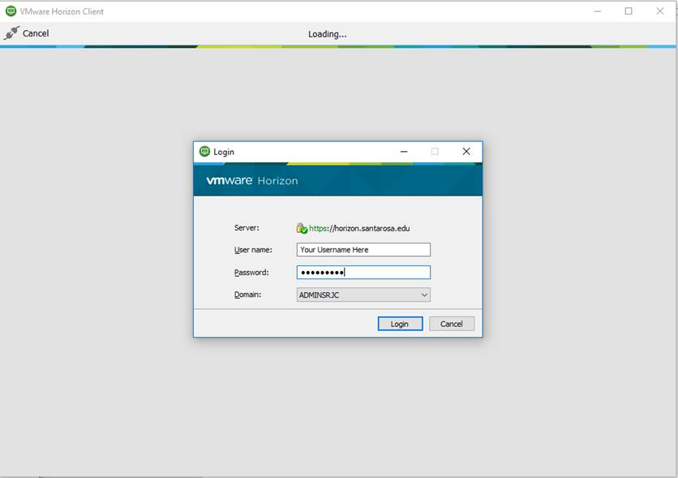

- Launch PRPP
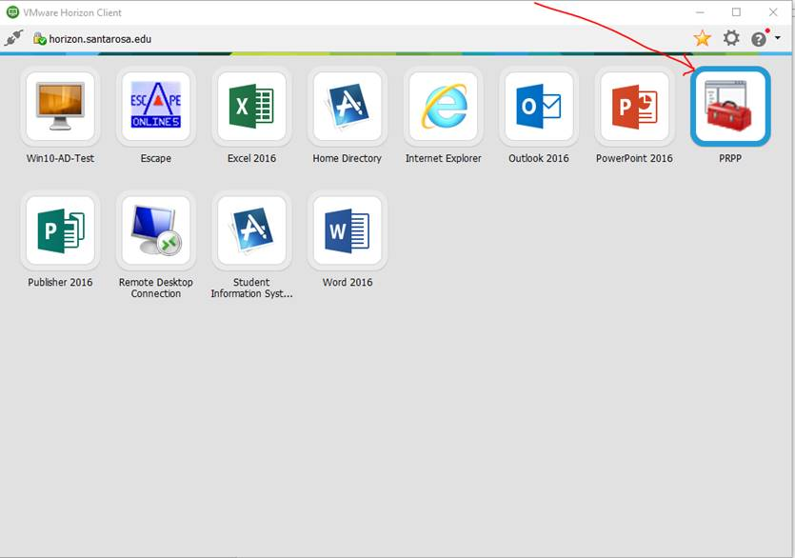
- Once the Horizon software is installed and the connection to https://horizon.santarosa.edu is established, the connection will be saved and you will not need to repeat step 6.

RESOURCE REQUESTS

What items go on which list?
When making resource requests in the PRPP template, put each item on only one list, not multiple lists; otherwise, unnecessary and confusing duplication will occur. Review the definitions below to determine where the request should be listed.

2.1b) Budget Requests
On this list, put budget requests for additional funds needed to support the unit. Essentially, any requests to enhance the 4000s or 5000s in the unit budget should be put on this list. For example, requests for copying funds, supplies, equipment maintenance, staff travel, and professional services. Exclude personnel costs 1000s, 2000s, or 3000s. Those are staffing requests. Exclude equipment (6000s), unless the equipment is less than $200 and usually purchased from the unit’s budget.

2.2c) Classified, Management, Student or STNC Requests
List any requests for new positions, increases to existing positions, and requests to convert STNC positions to permanent, ongoing.

2.4a) Desktop Technology requests
Desktop technology includes equipment for an individual faculty member, classified staff or manager that is used outside of the classroom (even if sometimes brought to class), such as a desktop computer, laptop, etc. for office use. Desktop technology requests are processed through the Institutional Technology Group (ITG). Requests should be initiated via the following link: https://it.santarosa.edu (look for the link to IT Equipment Requests). They are not prioritized in the PRPP process.

2.4c) Instructional Equipment Requests (Update every spring)
Section 2.4c has changed and should now only be used for Instructional Equipment requests. Software requests should now be entered in Section 2.4f (new section for requesting instruction/non-instructional software). Beginning in the 2019 PRPP cycle, ITG requests are now included in the PRPP, and ITG funded requests for the 2020 cycle must be submitted by March 25th.

List your Instructional Equipment requests in the table provided.
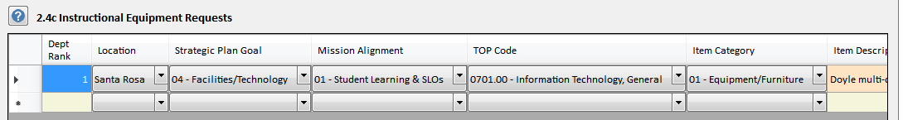
Rank for Instructional Equipment: Assign a numerical ranking that begins with the number 1 (1, 2, 3, 4…). Assign each item a separate rank (do not use any ranking more than once except to group related items that must be purchased together). Rank only those items that require funding. DO NOT rank those items for which you have confirmed funding and are including in this section only for documentation and planning purposes.
Cost: Cost, if known. Check the Media Services website at https://media.santarosa.edu/purchasing for commonly requested media items. Check the IT website at https://it.santarosa.edu/it-equipment-requests for commonly requested technology items.
When seeking funding through ITG (Institutional Technology Group) aka Bond funding refer to the guidelines below:
All requests must be entered into this section by March 25th for funding consideration for the next Fiscal Year. These requests will be reviewed by the ITG committee and VPs for recommendation for approval by the President. This process needs to be completed by April 1.
When seeking funding through IELM (Instructional Equipment/Library Materials) refer to the guidelines below:
To meet IELM categorical funding guidelines, instructional equipment is defined as equipment that is used in the classroom in support of instruction, such as media equipment, computers, lab equipment, media enhanced classroom audio-visual technology, chairs, and desks. This does not include instructional supplies, which are consumable in nature and cost less than $200 per item.
Definition of Instructional Equipment: Instructional Equipment is furniture, equipment, technology or other equipment used directly to serve students in an instructional setting, such as a classroom, lab, or playing field, or in student services setting, such as a Counseling office, a DRD lab or office, or other offices or that provide direct support to students.
The California Community College Chancellor’s Office states that instructional equipment is “for instructional and/or library or learning resource activities involving presentations and/or hand experience to enhance student learning and skill development.” Equipment is defined as “tangible District property of a more or less permanent nature that cannot be easily lost, stolen, or destroyed but which replaces, modernizes or expands an existing instructional program.” Furniture may be included, but land, buildings, and licensed motor vehicles are excluded. Any equipment purchased must meet these definitions as well as be worth more than $200.
A handy way to see if equipment qualifies as instructional equipment rather than supplies is to answer the five questions below. If you answer yes to any of them, the item should be classified as supplies rather than equipment.
- Does the item lose its original shape and appearance with use?
- Is it consumable, with a normal service life of less than one year? Does it last less than two years?
- Is it easily broken, damaged or lost in normal use?
- Is it usually more feasible to replace it with an entirely new unit than to repair it?
- Is it an inexpensive item? Does the small unit cost make it inadvisable to inventory the item?

Instructional Equipment Process
- Instructional Equipment/Library Materials (IELM): IELM funded recommendations are submitted by the Senior Dean for Learning Resources and Educational Technology to the appropriate vice president to finalize the priorities for their areas.
- CTEA and Bond Funding: Funding for CTEA/Perkins and Bond Technology allocations are handled through grant and committee processes not defined in this document.
- ITG: These requests will be reviewed by the ITG committee and VPs for recommendation for approval by the President.
NOTE: In identifying your instructional equipment needs, please make sure to include any additional costs for meeting the needs of people with disabilities, and for any impacts related to safety or facilities including the need for additional space, power, ventilation or plumbing.

2.4d) Non-Instructional Equipment and Technology Requests (Update every spring)
Non-instructional equipment is not used in a classroom, student services office, or to directly support instruction in a teaching venue. Some examples of non-instructional equipment include:
- Office chairs, desks, file cabinets, or shelves for classified staff or managers
- Office furnishings for faculty offices
- Vehicles if not used primarily directly to support instruction, such as a van used to transport students
- Technology like digital signage, outdoor music system, speakers for emergencies, gaming equipment for students to use for socializing, other technology equipment that is not directly educational but used on campus.
- Technology equipment related to the network, e.g., switches, wireless access points, battery backups, servers.

In Identifying your non-instructional equipment and technology needs, please make sure to include any additional costs for meeting the needs of people with disabilities, and for any impacts related to safety or facilities including the need for additional space, power, ventilation or plumbing.

List your Non-Instructional Equipment and Technology requests in the table provided.

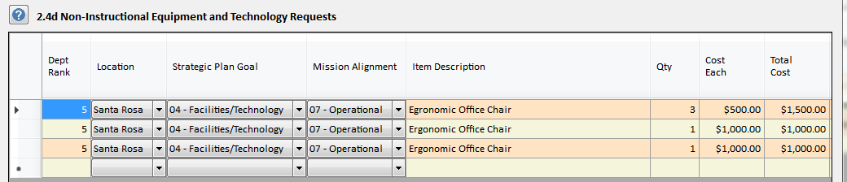

Rank for Non-Instructional Equipment and Technology: Assign a numerical ranking that begins with the number 1 (1, 2, 3, 4…). Assign each item a separate rank (do not use any ranking more than once except to group related items that must be purchased together).

Item Description: Make sure to put ITG Bond funded at the beginning of the Description if this is for technology equipment to be considered for ITG funding.
All ITG funding related requests must be entered into this section by March 25th for funding consideration for the next Fiscal Year. These requests will be reviewed by the ITG committee and VPs for recommendation for approval by the President. This process needs to be completed by April 1.

2.4f) Instructional/Non-Instructional Software Requests (Update every spring)
Use this section to request software. List your requests in the table provided.

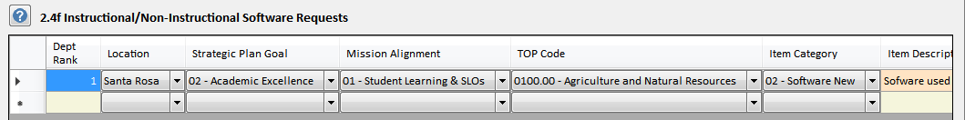

Rank for Software: Assign a numerical ranking that begins with the number 1 (1, 2, 3…). Assign each item a separate rank (do not use any ranking more than once except to group related items that must be purchased together). Rank only those items that require funding. DO NOT rank those items for which you have confirmed funding and are only including in this section for documentation and planning purposes.

Cost: Cost, if known. Check with IT for assistance in getting cost estimates.
Item Category: Make sure you have indicated Item Category “02-Software New” or “03-Software Renewal” for these selections. The definitions below may help you choose the appropriate category:
- Software/New – First-time purchase of department-related software for use in instructional programs. Include the cost of a single year subscription.
- Software/Renewal – Ongoing, department-related instructional software that is currently in use in instructional programs. Include the cost of a single year subscription.

Funding Source: Choose from the drop-down menu the funding source that best fits the item you are requesting.
- CTEA/Perkin’s
- General Fund
- Other
Department Software: The Senior Director, Information Technology recommends ranked software items to the appropriate vice president to finalize the priorities for their areas.

2.5a) Facilities
Generally speaking, a facilities request is an upgrade or changes to a medium to large area, such as:
- An upgrade to a single classroom or several classrooms
- An upgrade to an office suite or area
- An upgrade to restrooms, public spaces, or student services spaces
- A need for additional space – specify what kind of space and how much is needed
- Do not request entire buildings as those are major planning decisions; just state the space needs of the unit

Note: Maintenance Requests (do not include in the PRPP)
Facilities Operation can submit small repairs or upgrades as maintenance requests on the forms provided. Examples of maintenance items include:
- Carpet of a small area, such as a faculty office, a hallway, or a small office
- Cosmetic upgrades such as paint or replacement of ceiling tiles
- Fixing something that is broken, such as broken blinds or replacing a lighting fixture
- Addressing small safety problems, such as a broken tile or a slippery step

6.3a) Annual Plan: Ongoing Operations
List your goals for the next academic year (for major projects, you may need to project further into the future). To do this, go back through your PRPP document and identify areas that need improvement as well as goals and directions for the future. Include any goals or plans to reduce costs or share resources during this period of financial constraint.

6.3b) Institution-wide or Cross-Component Planning
This section is only viewable by the Vice Presidents and the President for high-level college planning.

CRITERIA FOR PRIORITIZATION OF RESOURCE REQUESTS

The criteria, below, are general guidelines used by clusters, supervising administrators and Vice Presidents for ranking the prioritization of requests.

Criteria | HIGH | MEDIUM | LOW
(a) Program effectiveness | Expand, modify, or enhance highly effective program;  Redirect or rebuild a less effective but vital program. | Expand, modify, or enhance an effective program;  Redirect or rebuild less effective but necessary program. | Expand, modify, or enhance less effective program;  Redirect or rebuild a less effective and less critical program.
(b) Addresses College Initiatives | Directly and Concretely | Substantively | Indirectly
(c) Urgency or Compliance | Needs to be done in 1 year time frame;  Serious safety issues that pose an immediate threat. | Should be done 2-3 year time frame;  Safety issues that do not pose an immediate threat. | Could be done 3-5 year time frame;  Longer-term safety considerations that do not pose an immediate threat.
(d) Cost effectiveness and/or  Revenue generation | Benefits significantly outweigh costs, generates significant revenue stream; and/or considerable cost savings. | Benefits outweigh cots; generates moderate revenue stream, and/ or moderate cost savings. | Benefits justify costs, generates modest revenue stream, and/ or modest cost savings.
(e) Meets student, institutional or community needs | High impact | Medium Impact | Low impact
Note: All initiatives and requests must provide sufficient information to allow ranking using these criteria.

INSTRUCTIONS FOR SUPERVISING ADMINISTRATORS
After the PRPP is submitted by an Editor, Supervising Administrators are asked to:
- Rank the instructional equipment requests in their cluster PRPPs in order of priority,
- Rank the non-instructional equipment and technology requests in order of priority, and
- Rank the department software requests in their cluster in order of priority.

How to rank all the requests in your cluster
- These instructions are the same for sections 2.4c (Instructional Equipment) AND 2.4f (Software requests)
- Log in to PRPP
- Open up one of the PRPPs in your cluster. It doesn’t matter which one. Do not open your Dean PRPP. The Dean PRPPs belong to the Vice President of Academic Affairs cluster.
- Click on the Excel icon toolbar button at the top of the screen to bring up the Export Spreadsheet Data screen.
- Click the “editing is disabled – enable editing” toolbar button on the Export screen (6th from the left) to enable editing. The red X on the toolbar button icon will disappear.
- Click the leftmost toolbar button on the Export screen to bring up the Select Records screen. The Component and Sub Component (Cluster) options will be grayed out and set to the name of your cluster. The Program/Unit option will default to all the program/units in your cluster. The screen should look like this:

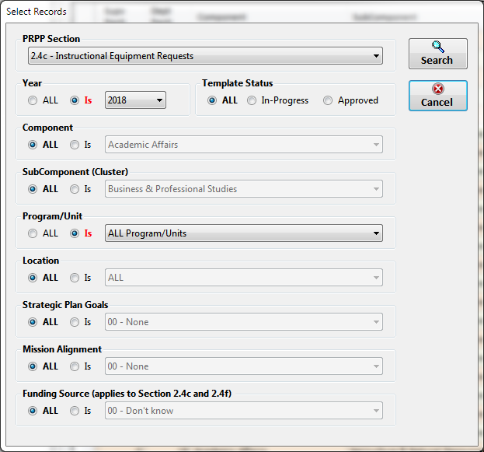
Note: A new search option “Funding Source” has been added to this screen and is enabled when Section 2.4c or 2.4f is selected.

Select the PRPP section you want to rank and click the Search button. All the requests in your cluster will be displayed in the grid. You can then add your cluster rankings in the Supv Rank column. You cannot add or delete records from the grid but you can edit the other columns if necessary. The grid should look like this:
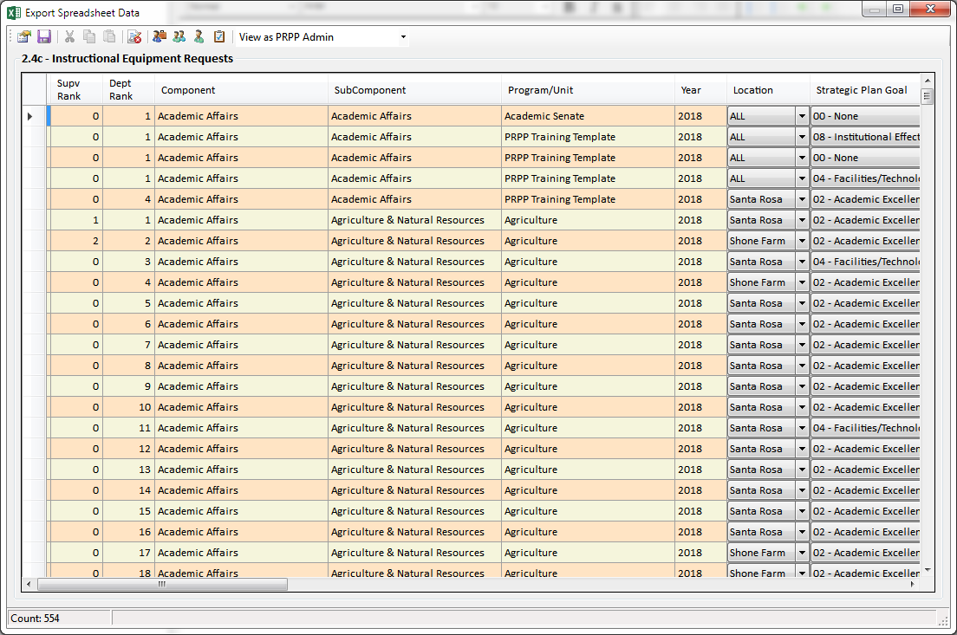
List your instructional equipment requests and instructional/non-instructional software requests in rank order, in the tables provided.

Rank for Instructional Equipment: Assign a numerical ranking that begins with the number 1 (1, 2, 3, 4…). Assign each item a separate rank (do not use any ranking more than once except to group related items that must be purchased together). Rank only those items that require funding. DO NOT rank those items for which you have confirmed funding and are including in this section only for documentation and planning purposes.

Rank for Software: Assign a numerical ranking that begins with the number 1 (1, 2, 3…) Assign each item a separate rank (do not use any ranking more than once except to group related items that must be purchased together). Rank only those items that require funding. DO NOT rank those items for which you have confirmed funding and are only including in this section for documentation and planning purposes.
After the ranking is complete, all items are exported to a master database for allocation based on available funds.

Instructional, Non-Instructional Equipment and Software Process
Instructional Equipment/Library Materials (IELM): IELM funded recommendations are submitted by the Senior Dean for Learning Resources and Educational Technology to the appropriate vice president to finalize the priorities for their areas.

Department Software: The Senior Director, Information Technology recommends ranked software items to the appropriate vice president to finalize the priorities for their areas.
CTEA and Bond Funding: Funding for CTEA/Perkins and Bond Technology allocations are handled through grant and committee processes not defined in this document.

ITG: These requests will be reviewed by the ITG committee and VPs for recommendation for approval by the President.

REFERENCE INFORMATION
The following information is provided as a handy reference for particular sections of the PRPP.

Strategic Plan Goals
These goals are referenced in Mission Alignment (Section 1.1b), resource requests (Section 2) and planning (Section 6).

- NONE
- Student Success – Support development of the whole student from early college awareness through successful completion of educational and career goals.
- Academic Excellence- Foster learning and academic excellence by providing effective programs and services.
- Diverse Communities – Serve our diverse communities and strengthen our connections though engagement, collaboration, partnerships, innovation, and leadership.
- Facilities/Technology – Provide, enhance, integrate, and continuously improve facilities and technology to support learning and innovation.
- Sustainability – Establish a culture of sustainability that promotes environmental stewardship, economic vitality, and social equity.
- Healthy Organization – Cultivate an inclusive and diverse organizational culture that promotes employee engagement, growth, and collegiality.
- Financial Resources – Pursue resource development and diversification while maintaining responsible fiscal practices and financial stability.
- Institutional Effectiveness – Continuously improve institutional effectiveness in support of our students, staff, and communities.

Mission Alignment
Mission statements are referenced in are referenced in Mission Alignment (Section 1.1b), resource requests (Section 2) and planning (Section 6).

- NONE
- Student Learning – We focus on student learning by preparing students for transfer; by providing responsive career and technical education; and by improving students’ foundational skills.
- Student Services – We provide a comprehensive range of student development programs and services that support student success and enrich student lives.
- Vitality/Equality/Stewardship – We support the economic vitality, social equity and environmental stewardship of our region.
- Personal/Professional Growth – We promote personal and professional growth and cultivate joy at work and in lifelong learning.
- Civic Engagement – We foster critical and reflective civic engagement and thoughtful participation in diverse local and global communities.
- Continuous Improvement - We regularly assess, self-reflect, adapt, and continuously improve.
- Operational – Operational resources requests that do not fit into a category above.

Institutional Student Learning Outcomes (I-SLOs)
I-SLOs are referenced in Section 4.2a, Key Courses or Services that address Institutional Outcomes.

1a Perform mathematical operations (Foundational Skills)
1b Utilize technology (Foundational Skills)
1c Read and write at the college level (Foundational Skills)
2a Develop self-awareness and confidence (Personal Development and Management)
2b Manage resources, such as time and money, in order to advance personal and career goals (Personal Development and Management)
2c Maintain or improve health (Personal Development and Management)
2d Appreciate the value of lifelong learning (Personal Development and Management)
3a Listen actively and respectfully (Communication)
3b Speak coherently and effectively (Communication)
4a Locate, analyze, evaluate, and synthesize relevant information (Critical Analysis)
4b Draw reasonable conclusions in order to make decisions and solve problems (Critical Analysis)
- Creatively respond to ideas and information (Creativity)
6a Recognize and acknowledge individual and cultural diversity (Intercultural Literacy and Interaction)
6b Practice respectful interpersonal and intercultural communication (Intercultural Literacy and Interaction)
6c Recognize and understand the ideas and values expressed in the world’s cultural traditions (Intercultural Literacy and Interaction)
7 Understand and demonstrate personal, civic, social, and environmental responsibility and cooperation in order to become a productive local and global citizen (Responsibility)

